ASSIGNMENT - 1 : **IMPLEMENT BASIC ISP**

**INTRODUCTION**

This report provides a detailed overview of a Streamlit-based image processing application designed to enhance RAW images. The tool integrates multiple image processing techniques, including demosaicing, white balance, gamma correction, denoising, and sharpening, allowing users to adjust parameters via interactive sliders.

**PURPOSE OF THE APPLICATION**

The application aims to process RAW image files to produce visually enhanced results. It provides flexibility to users by enabling them to select specific processing steps and adjust parameters interactively, making it suitable for photographers, researchers, and enthusiasts working with RAW image formats.

**KEY FEATURES**

1. **User-Friendly Interface**
   * Built with Streamlit, the application offers a simple and intuitive UI.
   * Users can upload a RAW image file (e.g., .RAW, .DNG, or .PNG).
2. **Processing Steps**
   * Users can choose from a list of pre-defined image processing steps.
   * Steps include **Demosaic**, **White Balance**, **Gamma Correction**, **Denoise**, and **Sharpen**.
3. **Parameter Control**
   * Sliders are provided for fine-tuning various parameters, ensuring a tailored image processing experience.

**LIBRARIES USED**

The application leverages several libraries to implement its functionalities efficiently:

* **Streamlit:** For building the interactive user interface.
* **NumPy:** To handle and process image arrays efficiently.
* **scikit-image (skimage):** For advanced image processing tasks such as edge detection and filters.
* **SciPy:** For Gaussian filtering during demosaicing and denoising processes.
* **Pillow (PIL):** To manipulate and enhance images, including sharpening and color adjustments.
* **OpenCV:** For additional image processing tasks like color balance.

**IMAGE PROCESSING STEPS**

1. **Demosaicing**
   * Converts a grayscale RAW image captured by cameras using a Bayer filter into a full-color image.
   * Uses interpolation to estimate missing color values for red, green, and blue channels.
   * Implements Gaussian filtering for smoothing color transitions.
2. **White Balance**
   * Adjusts the color balance by normalizing pixel intensities across RGB channels.
   * Compensates for variations in lighting conditions to achieve a neutral color tone.
3. **Gamma Correction**
   * Enhances the brightness and contrast of the image by applying a non-linear transformation.
   * Users can adjust the gamma value using a slider, providing control over image brightness.
   * Includes color enhancement for a more vibrant output, with a saturation factor slider.
4. **Denoising**
   * Reduces noise in the image while preserving edges and details.
   * Utilizes Gaussian filtering, with a customizable sigma value slider for controlling the strength of the denoising.
5. **Sharpening**
   * Enhances the image's details and texture using an adjustable sharpening filter.
   * A "Sharpen Amount" slider allows users to control the level of sharpening.

**INTERACTIVE CONTROLS**

The tool provides the following sliders for parameter adjustments:

* **Gamma Correction Value:** Adjust the intensity of gamma correction (Range: 1.0 to 3.0).
* **Denoise Sigma:** Control the level of noise reduction (Range: 0.5 to 5.0).
* **Sharpen Amount:** Set the intensity of sharpening (Range: 0.5 to 3.0).
* **Edge Weight:** Modify the enhancement weight for edges (Range: 0.5 to 3.0).
* **Color Saturation Factor:** Adjust the saturation of colors (Range: 0.5 to 3.0).

These controls provide users with a dynamic and customizable experience to produce optimal results based on their requirements.

**WORKFLOW**

1. **Image Upload**
   * Users upload a RAW image, which is displayed in its original state.
2. **Processing Steps Selection**
   * Users select one or more steps from the sidebar to apply to the image.
3. **Parameter Adjustment**
   * Parameters for each processing step can be adjusted via sliders.
4. **Image Processing**
   * The selected steps are executed in sequence, and the final processed image is displayed.
5. **Observations**
   * A log is displayed to indicate which steps have been applied to the image.

**OBSERVATIONS**

* **Demosaic**

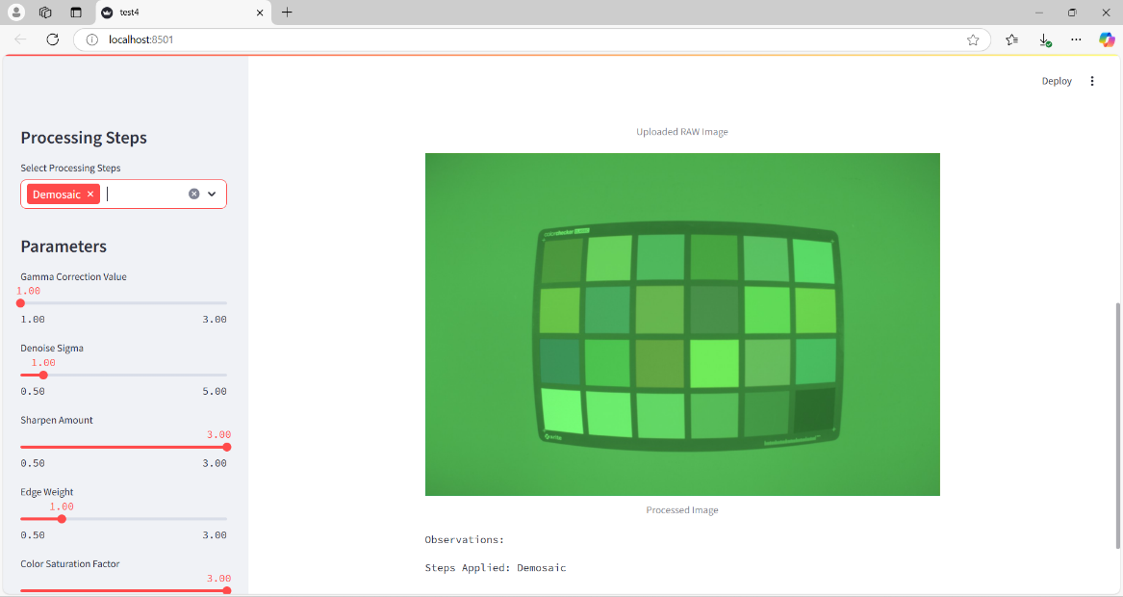

* **Demosaic + White Balance**

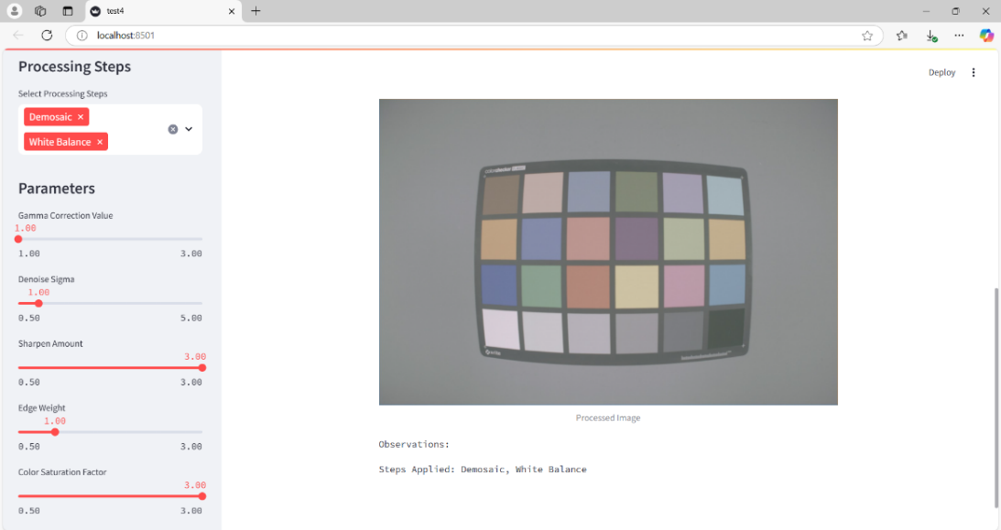

* **Demosaic + White Balance + Denoise**

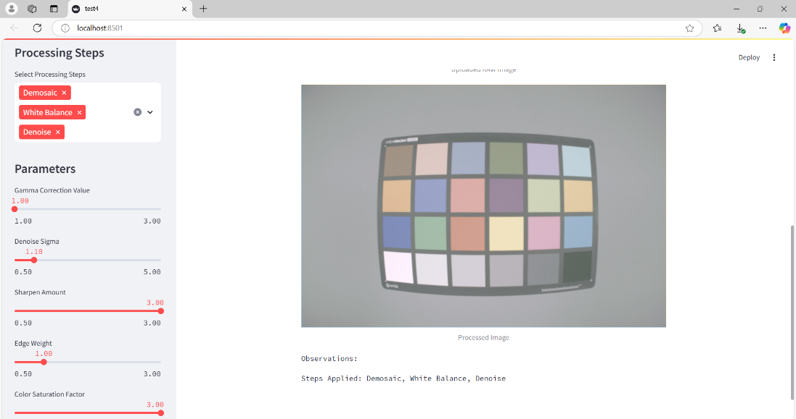

* **Demosaic + White Balance + Denoise + Gamma Correction**

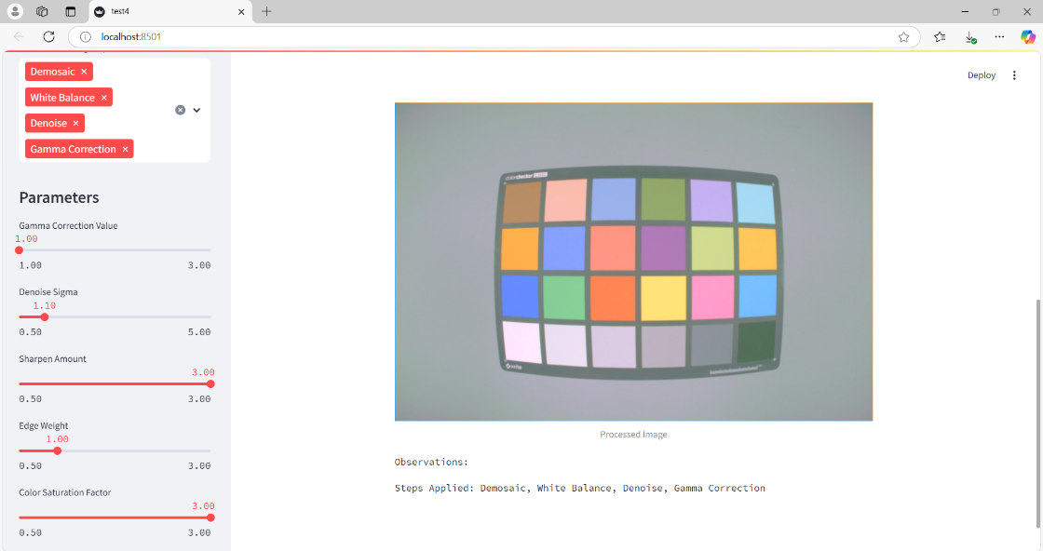

* **Demosaic + White Balance + Denoise + Gamma Correction + Sharpen**

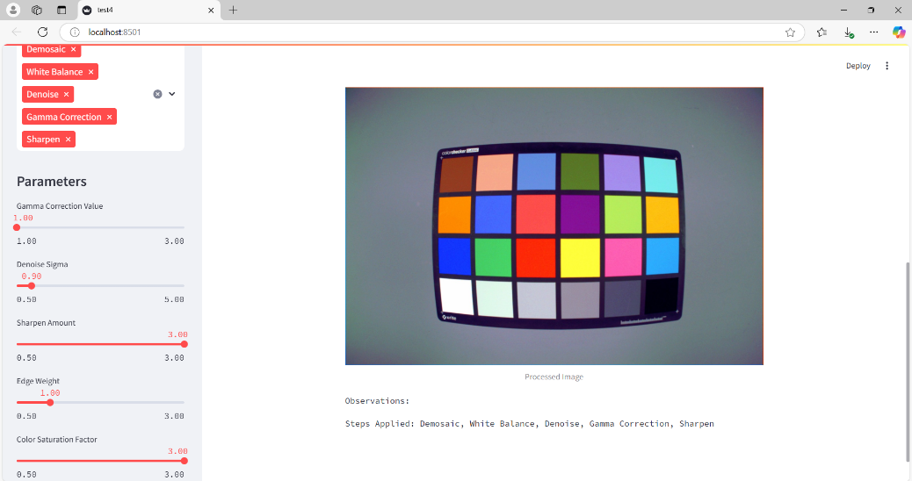

**CONCLUSION**

The RAW Image Signal Processing Tool provides an efficient and interactive platform for processing RAW images. By incorporating multiple processing techniques with parameter customization, users can enhance their images according to their specific needs. The inclusion of sliders for control ensures precise and user-defined adjustments, making the tool both versatile and practical. The integration of powerful libraries like Streamlit, NumPy, scikit-image, SciPy, Pillow, and OpenCV ensures a robust implementation.